Automata and Compiler Design
Assignment-1

Q1. Design the finite automata which recognizes the string starts with a and ends with b over the set of input alphabet = {a,b}

Q2. Construct DFA equivalent to NDFA.
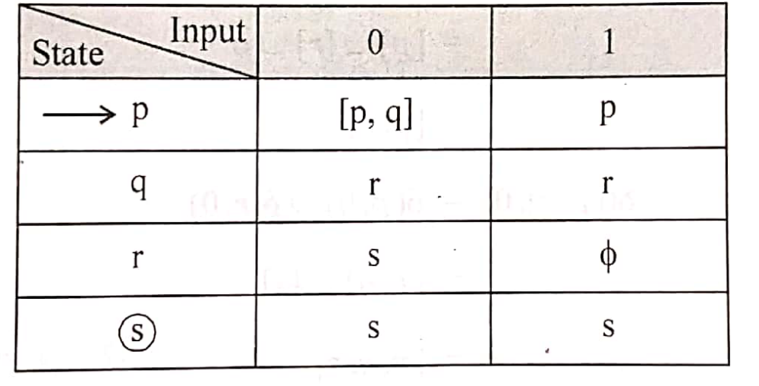

Q3. Remove Null moves from the following Automata
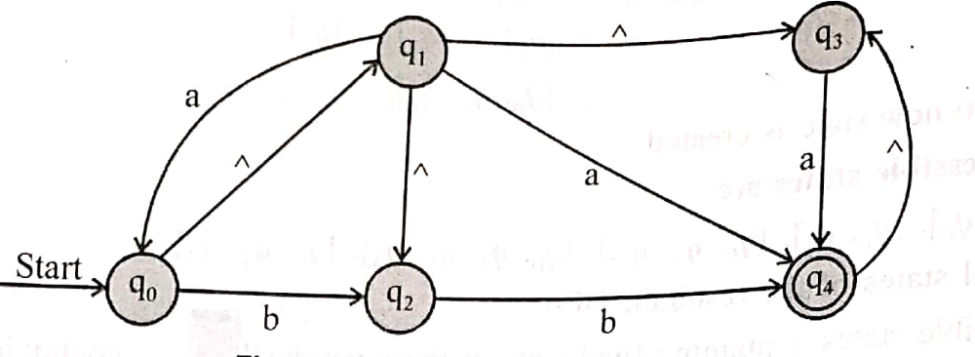

Q4. Convert Mealy Machine to equivalent Moore Machine
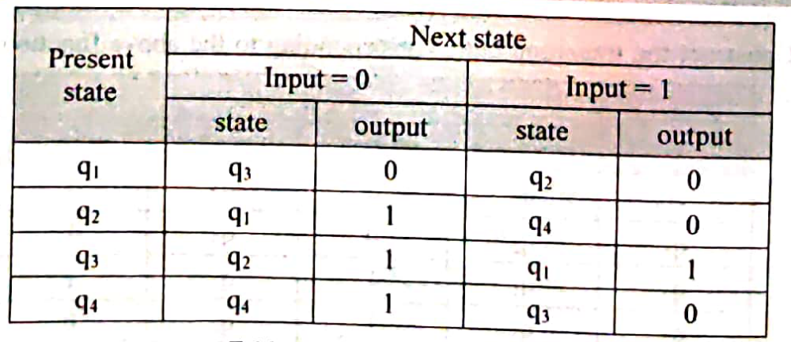
Q5. Minimize the Finite Automata.
